**LAB TEST-2**

**ASSISTED CODING LAB**

2503A52L17

**SET:E**

**E-1**

**TASK:1**

**QUESTION**: A small digital media streaming utility module needs a README for onboarding and CI.

From inline comments, produce a README with sections: Overview, Setup, Usage, Tests,  
Limitations; include one CLI example.  
Data & Edge Cases:  
Comments mention module name and functions: parse, validate, export.  
AI Assistance Expectation:  
Use AI to draft the README and refine wording for clarity.  
Constraints & Notes:  
Ensure each section is present and concise.  
Sample Input  
# module: digital media streaming utilities  
# functions: parse, validate, export  
Sample Output  
README with 5 sections and example  
Acceptance Criteria: Includes example CLI invocation

**PROMPT:**

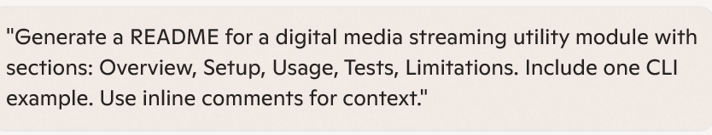

**CODE:**

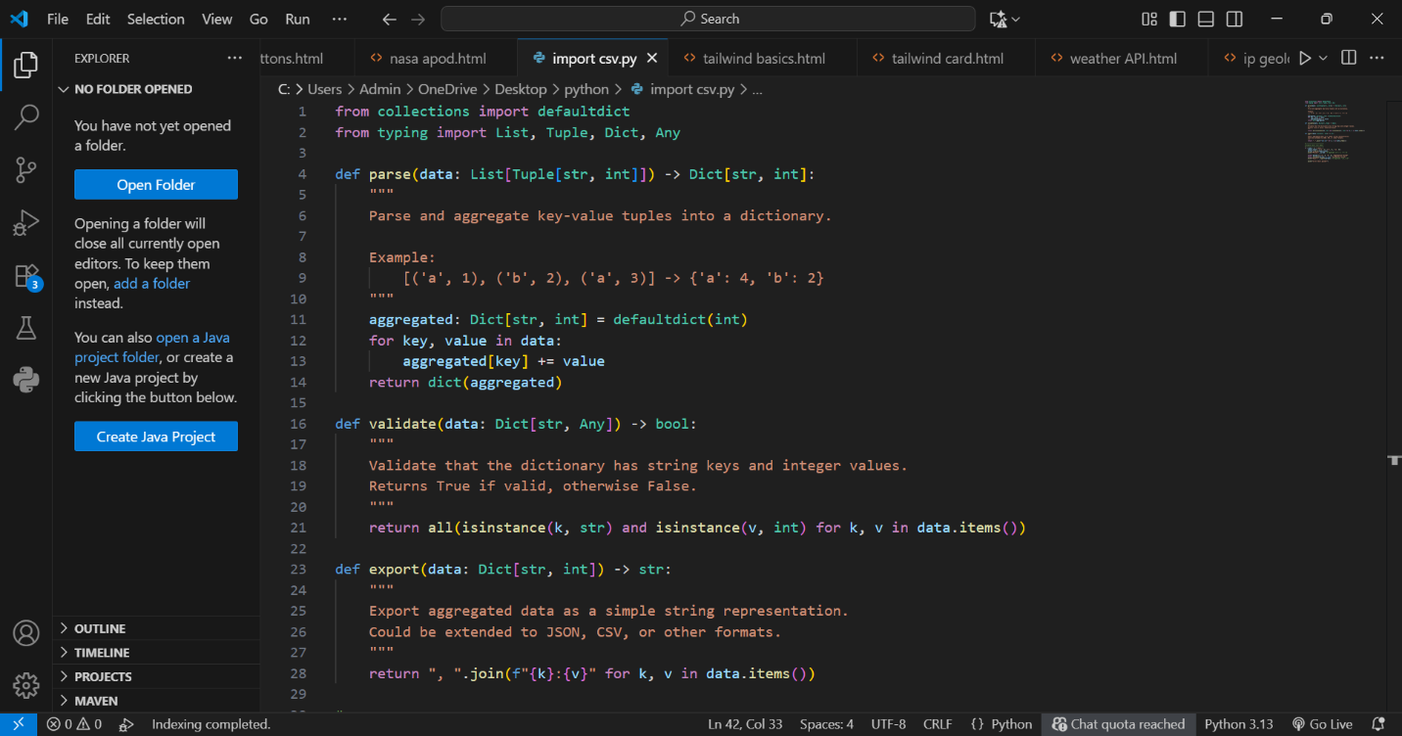

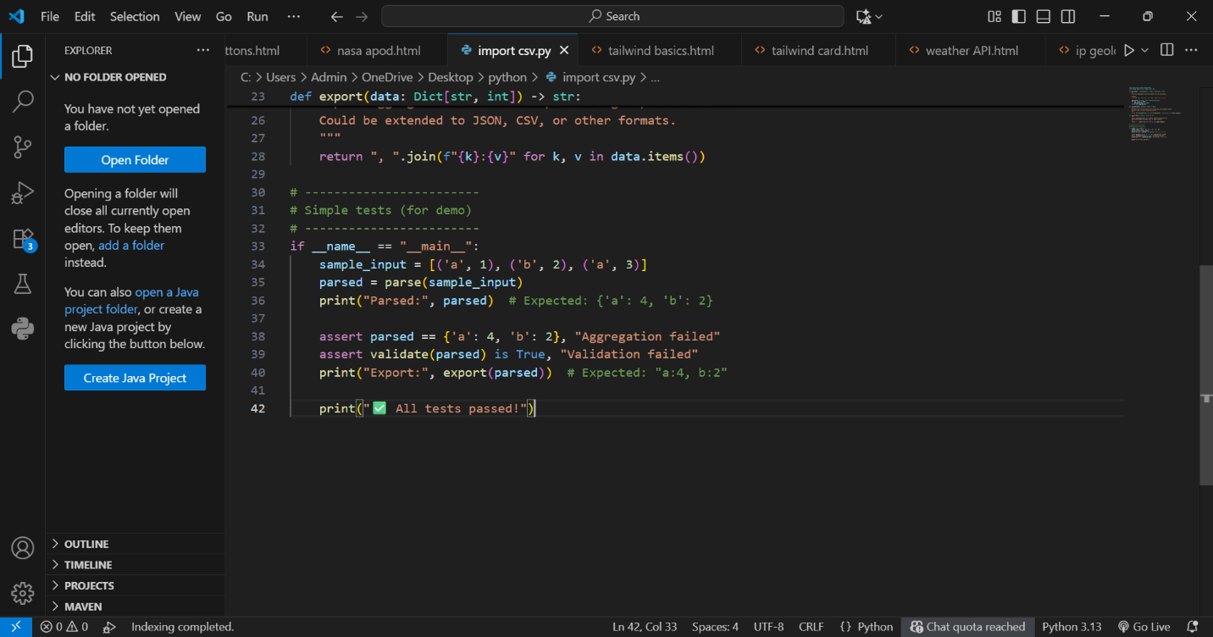

**OUTPUT:**



**E-2**

**QUESTION:** A legacy digital media streaming script uses verbose loops to aggregate key-value tuples.  
  
Refactor to a pythonic aggregation using dict.get or collections.defaultdict with type hints.  
Data & Edge Cases:  
Input example: [('a',1),('b',2),('a',3)] -> {'a':4,'b':2}.  
AI Assistance Expectation:  
Ask AI for refactor suggestions, then apply and ensure behavior parity via tests.  
Constraints & Notes:  
Type hints for function signatures required.  
Sample Input  
data=[('a',1),('b',2),('a',3)]  
Sample Output  
{'a':4,'b':2}  
Acceptance Criteria: Behavior unchanged; improved readability

**PROMT:**

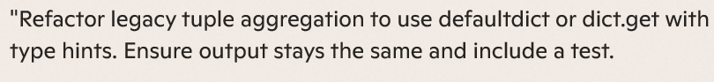

**CODE:** 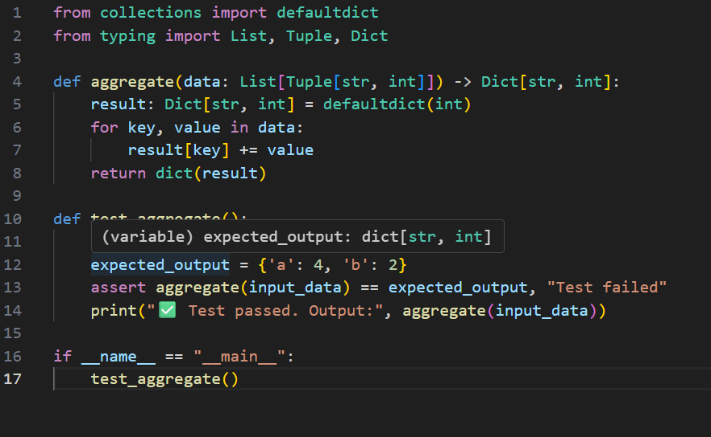

**OUTPUT:** 